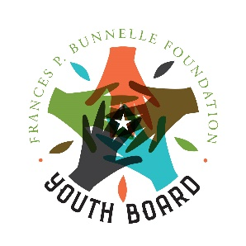
Youth Board Application
Please print (Blue or Black Ink) or type your information below.

Name: Date of Birth: School: Current Grade: 10th or 11th (please circle) Address: Email: Phone: Cell:

List all extracurricular, school-based activities in which you have participated as well as any volunteer work using the space below. Use additional sheets if necessary.

School Year | Activity | Position Held
Why do you want to be on the Youth Board?

What do you hope to learn from your experience on the Youth Board?

What skills, abilities, or qualities will you bring to the Youth Board?

Please check all that apply.
I am able to attend Youth Board monthly meetings.
I am able to commit my time and energy to the Youth Board.
I am able to attend the Youth Board Retreat June 20-June 22, 2023.
I am able to plan, organize, and carry out events and activities.
I am able to work as part of a team.
I am able to be a leader and an example to my peers by following policies and guidelines laid out by the Youth Board.
I will work to make the Youth Board the best that it can be.
I am committed to representing the Youth Board at home, at school, and in my community.
Recommendation Letters
Each applicant must provide a Letter of Recommendation from a teacher, coach, employer, etc. Letters from family members or friends are not acceptable. Recommendations may be submitted along with the application, or they can be emailed directly to
Ashley Nelson – anelson@bunnelle.org.

Note to Student:

By signing this application, you are committing to attending meetings and other scheduled events. You are acknowledging that you understand that you cannot make other commitments for this time period.

Student Signature: Date:

Print Name:

Note to Parent/Guardian:

By signing this application, you give permission for your child to participate in the Frances P. Bunnelle Foundation’s Youth Board Program.

Parent/Guardian Signature: Date:

Print Name:

Applications are due by: February 28, 2023
Return Applications To:
Frances P. Bunnelle Foundation
Attn: Ashley Nelson
PO Box 1965 Pawleys Island, SC 29585 OR EMAIL TO: anelson@bunnelle.org

